API Driven Cloud Native Solutions

Assignment 2

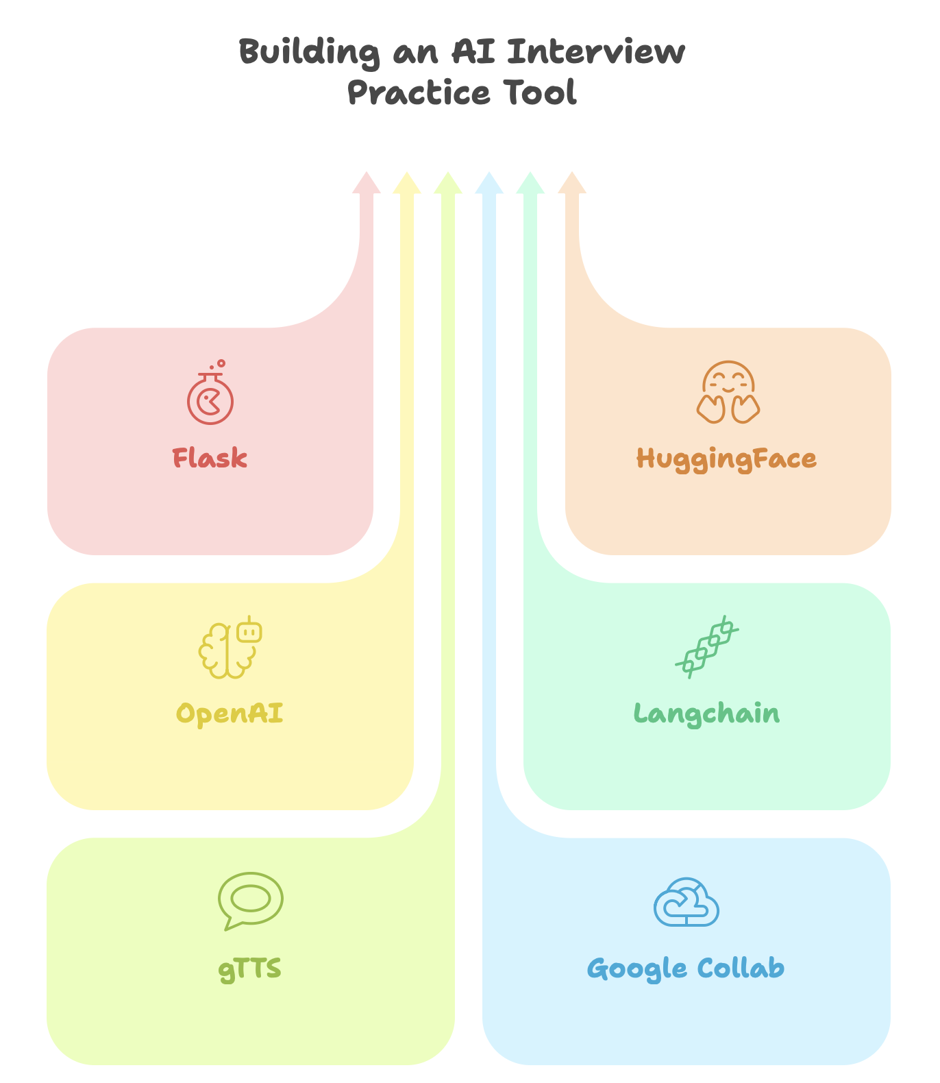

# Group Details

**Group No:** 12

**Group Member Names with Contribution:**

|  |  |  |  |  |
| --- | --- | --- | --- | --- |
| **Sl. No** | **BITS ID** | **Name** | **Contribution of team member (Qualitative)** | **Percentage Contribution (Out of 100) Quantitative** |
| 1 | 2023MT03552 | Amuthavarsni R | Fluency Feedback, Question Generation and Fine tuning and Integration | 25% |
| 2 | 2023MT03517 | Shah Pratik Kiran | Voice to Text and Text to Voice Integration | 25% |
| 3 | 2023MT03577 | Pradhan Vaishnavi Mangesh | Application UI, DB Connection and Integration | 25% |
| 4 | 2023MT03586 | P Rahul Kumar | Model Fine Tuning Base Design and Report | 25% |

# Overview

## Domain - Education – AI-based Interview PRactice Tool

This project is focused on the Education domain, with a specific objective of enhancing interview preparation for students and job seekers. The system acts as an intelligent mock interview assistant, offering an automated and interactive environment that mimics real-life interview scenarios. It allows candidates to respond using voice or text, receive dynamic questions, and get instant evaluation and feedback powered by AI.

The solution aims to:

* Improve candidate readiness through repeated practice.
* Provide personalized and constructive feedback.
* Make interview preparation accessible, scalable, and engaging.

To implement this solution, the project combines two AI categories:

* Natural Language Processing (NLP):
  + For tasks like generating questions, evaluating answers, and providing fluency feedback.
* Speech Recognition:
  + For enabling voice-based interaction, converting speech to text and vice versa.

These AI capabilities work together to form a cohesive system that supports the candidate throughout their interview journey—from question delivery to performance evaluation.

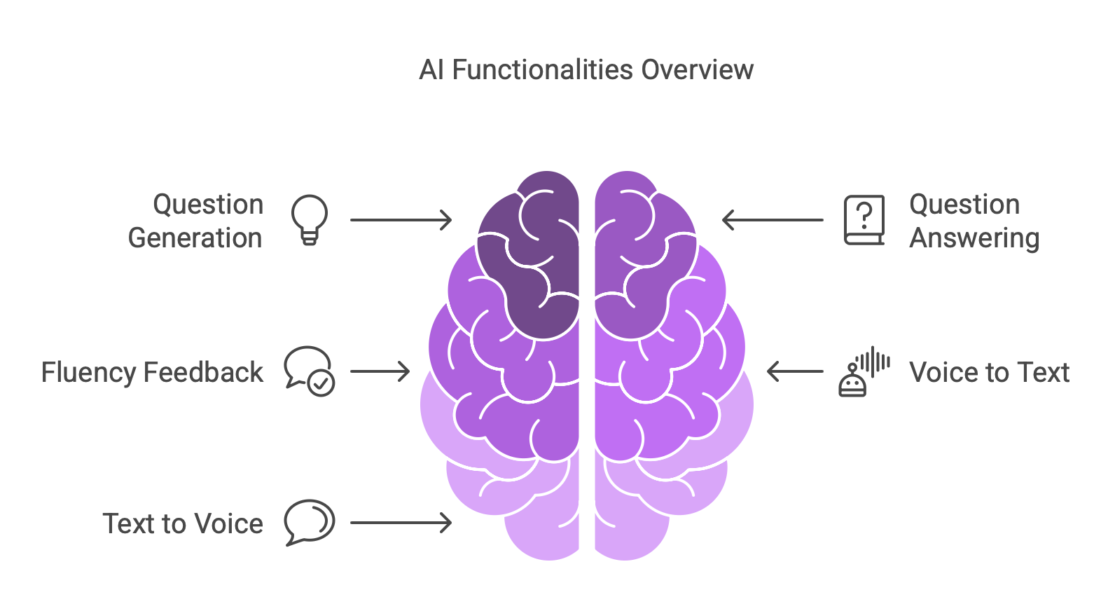

## Selected Sub-Tasks

|  |  |  |
| --- | --- | --- |
| **Categories** | **Sub-Task** | **Description** |
| NLP | Question Generation | Generate interview questions using OpenAI GPT |
| NLP | Question Answering | Use fine-tuned DistilBERT to understand and score candidate answers |
| NLP | Fluency Feedback | GPT model gives natural language feedback on grammar, tone, and completeness |
| Speech Recognition | Voice to Text | OpenAI Whisper converts candidate’s spoken answers to text |
| Speech Recognition | Text to Voice | gTTS converts generated questions into spoken form for the user |

## Models Used

|  |  |  |
| --- | --- | --- |
| **Sub-Task** | **Model** | **Provider** |
| Question Generation | GPT-3.5 (LLM) | OpenAI |
| Question Answering | DistilBERT (fine-tuned on QA) | Hugging Face |
| Fluency Feedback | GPT-3.5 | OpenAI |
| Voice to Text | Whisper | OpenAI |
| Text to Voice | gTTS (Google Text-to-Speech) | Google |

# API Integration and application design

## Technologies Used

* The Following are the technologies used in the application implementation:
  + Flask – Web Application Framework
  + HuggingFace - Model hosting and fine-tuning platform
  + OpenAI API - LLM integration (GPT, Whisper)
  + Langchain – Model Orchestration and Integration
  + gTTS – Text to Speech conversion

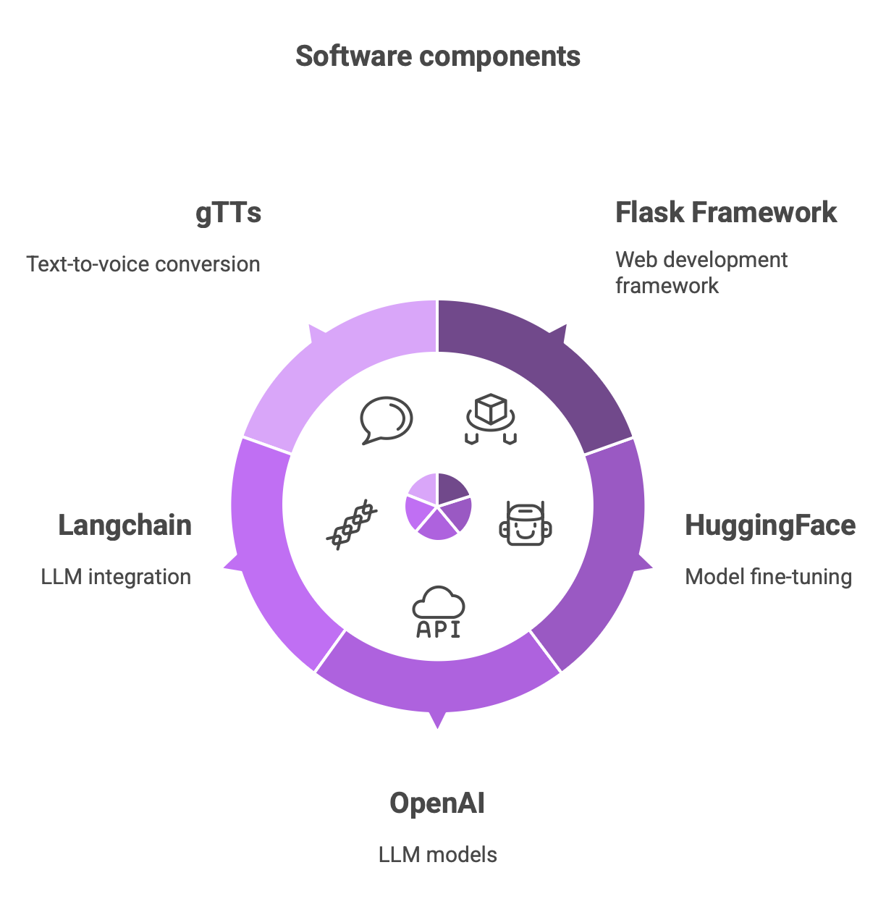

## Model Fine-Tuning

* Dataset Used:
  + SQuAD (Stanford Question Answering Dataset) – a widely used benchmark dataset for reading comprehension and QA tasks.
* Model Fine-Tuned:
  + **distilbert-base-uncased**
  + Task: Question Answering
  + Platform: HuggingFace, Collab
  + Training Details: Fine-tuned on SQuAD v1.1 format where the model learns to predict answer spans from a given context paragraph in response to a question.
* Purpose:
  + To accurately assess candidate responses by extracting and comparing expected answers from context, improving the feedback and scoring quality during interviews.

# Screenshots and Outputs

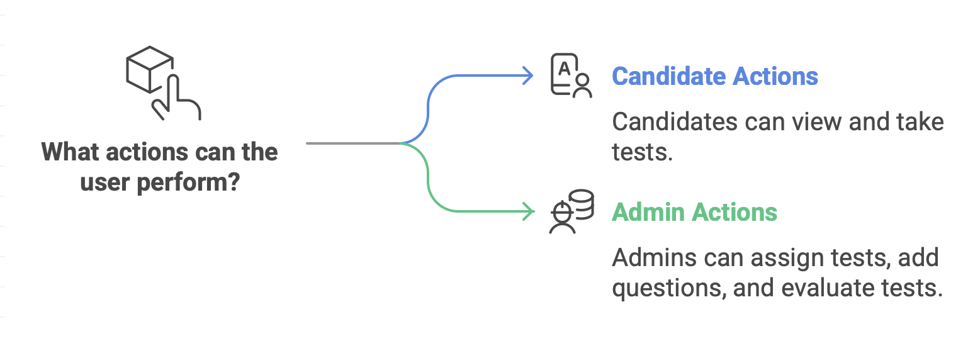

## Candidate Dashboard

### Candidate Home

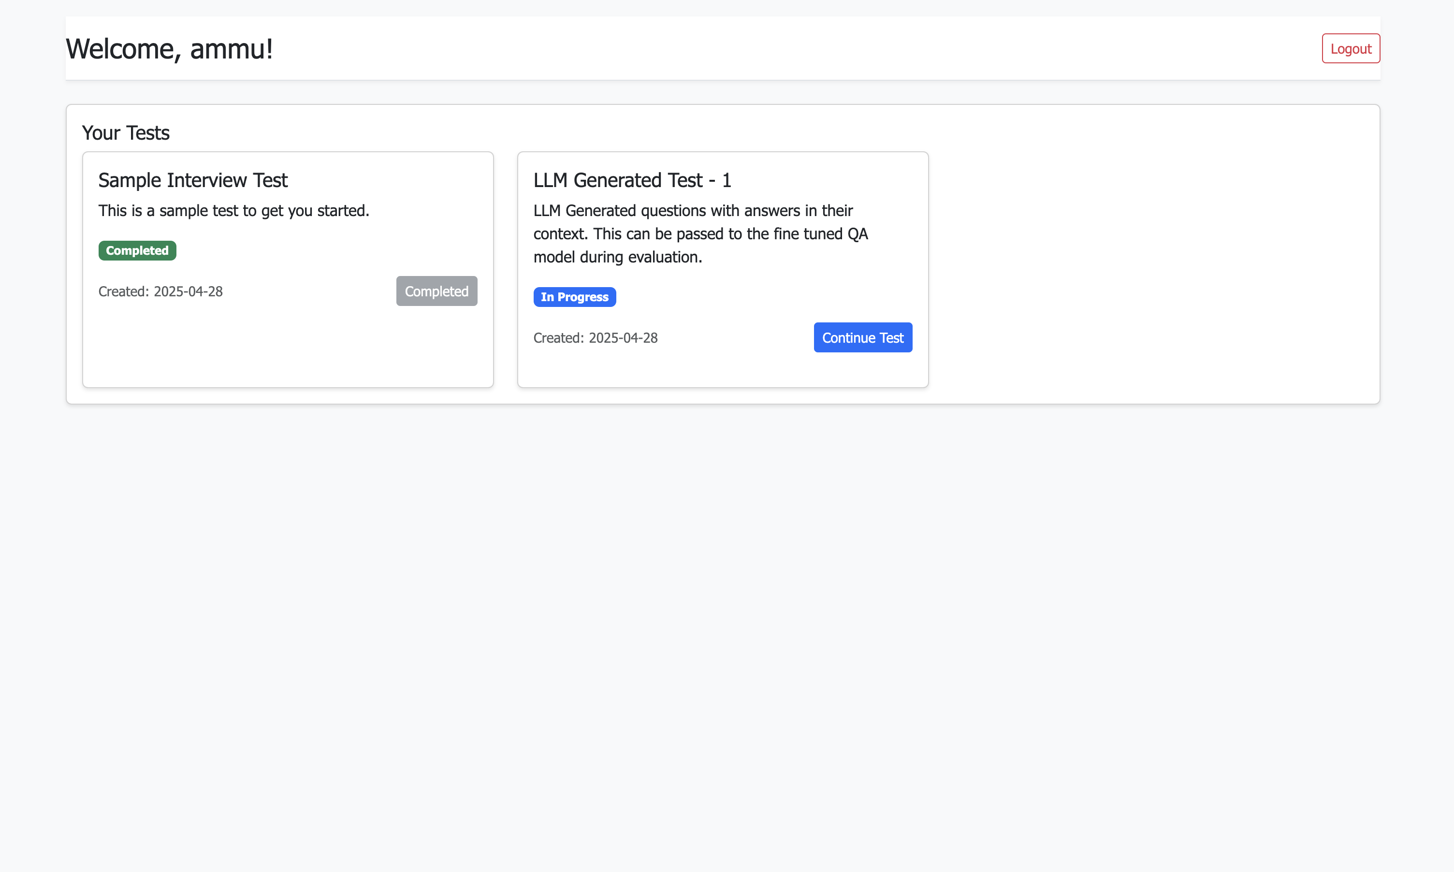

### Candidate Test

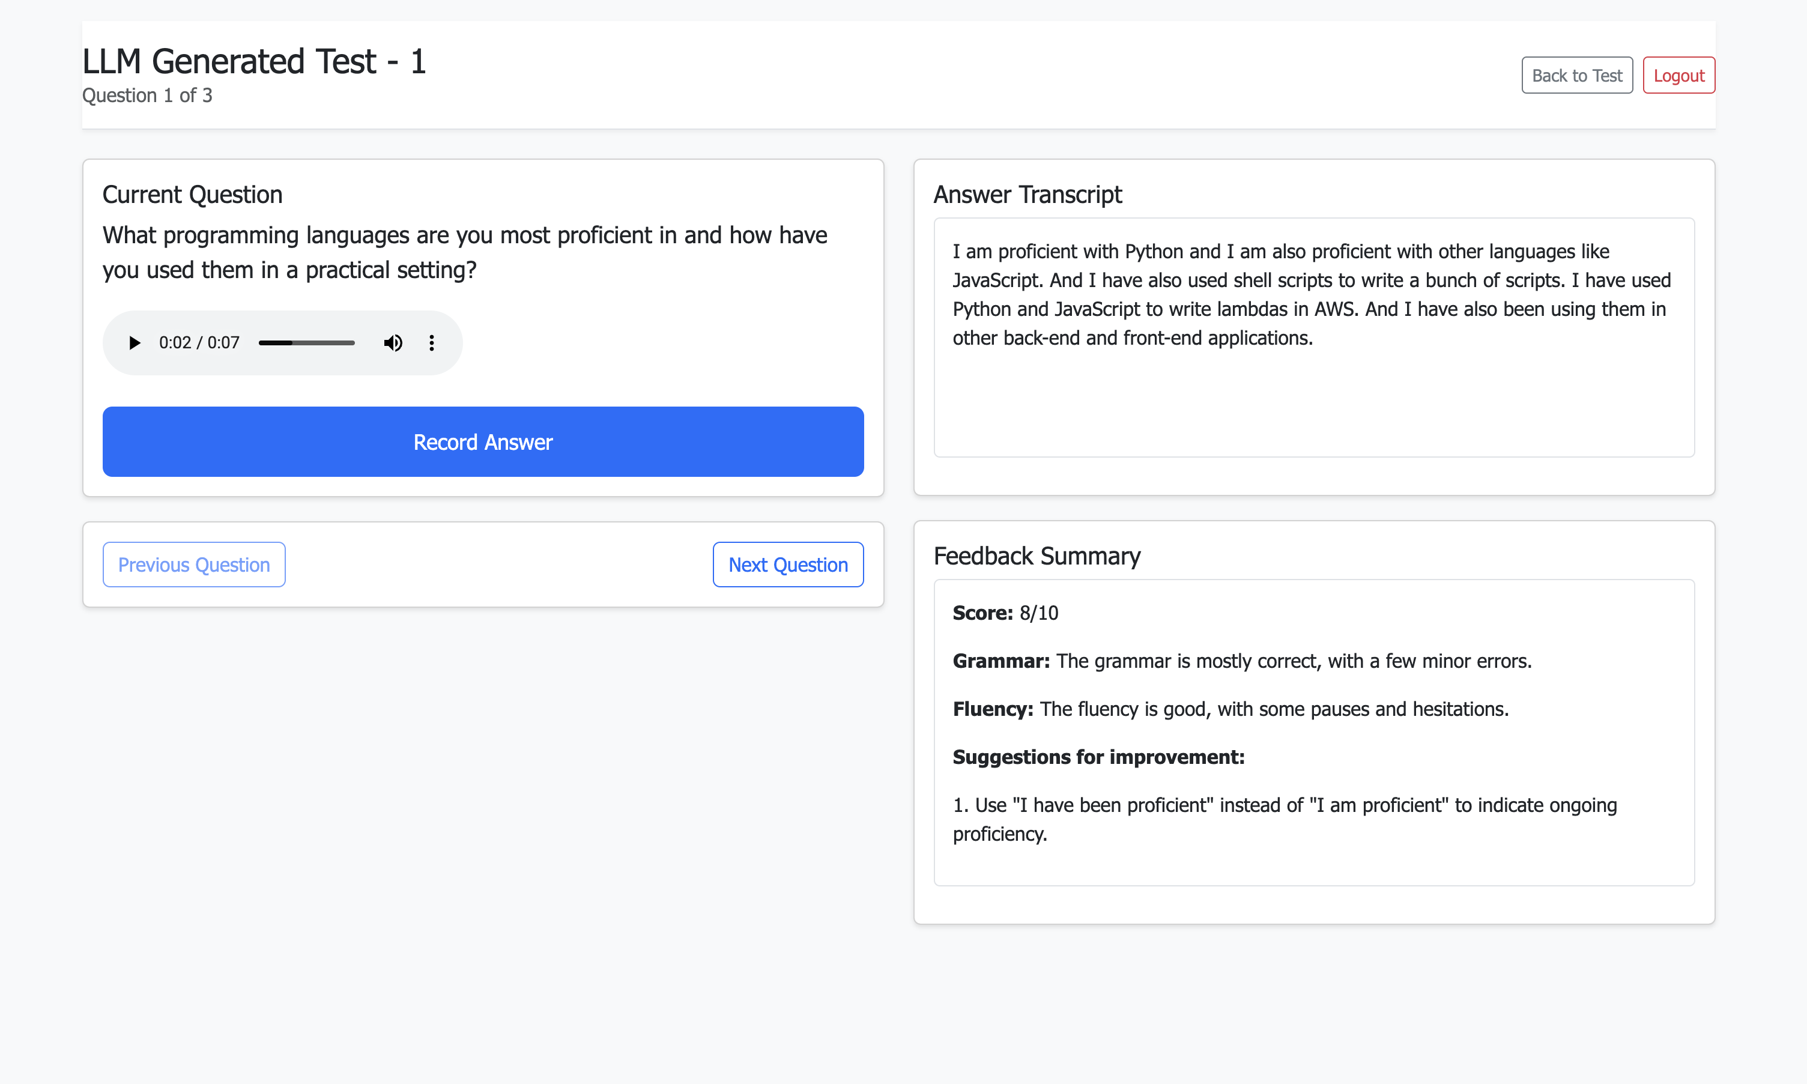

# Admin dashboard

### Admin Home

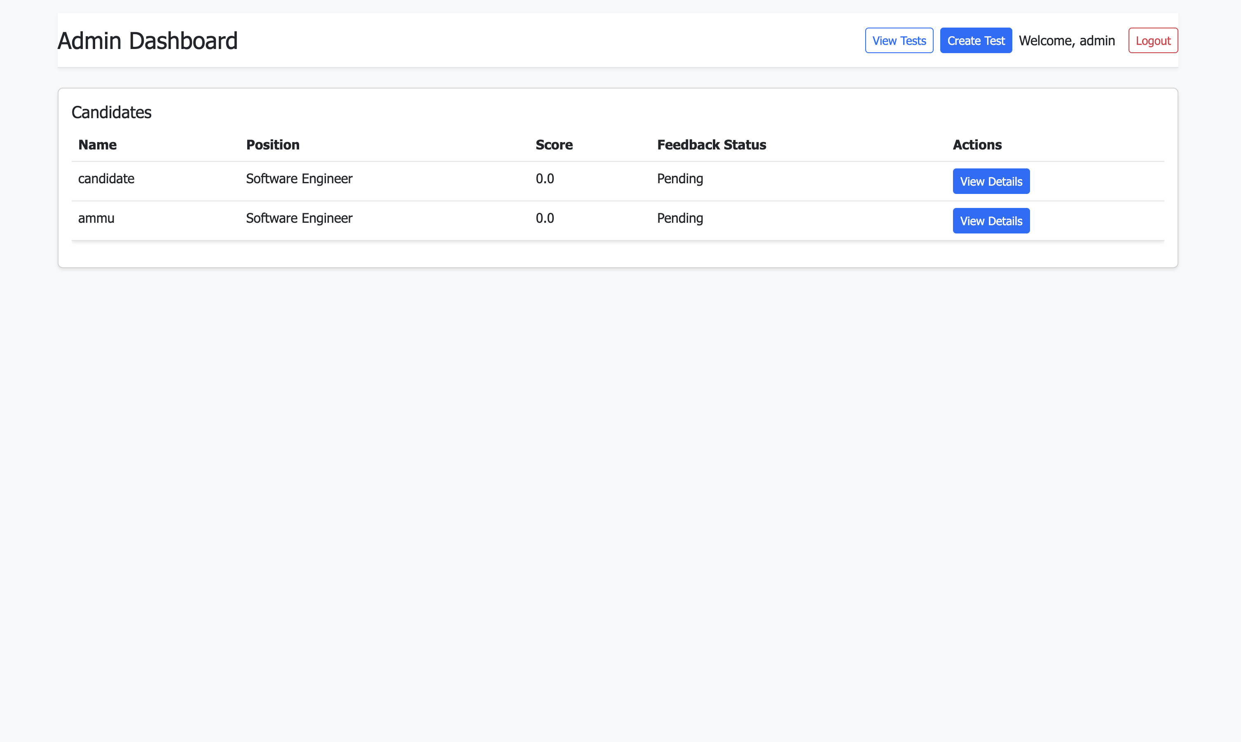

### Admin Tests

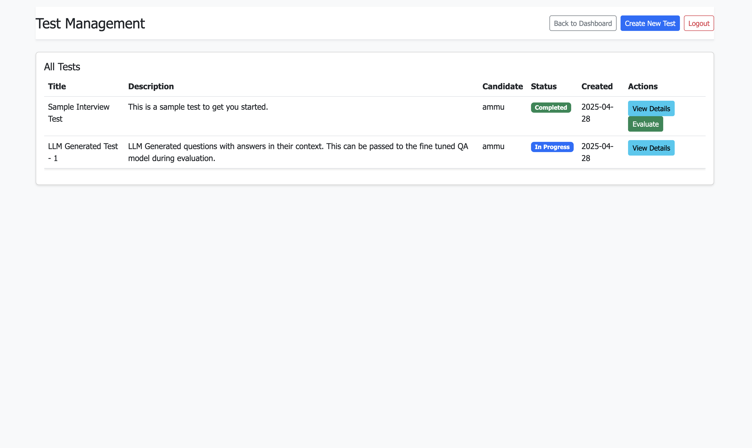

### Admin Evaluate

